# Assignment Management System

## Class Elaboration:

Authentication:

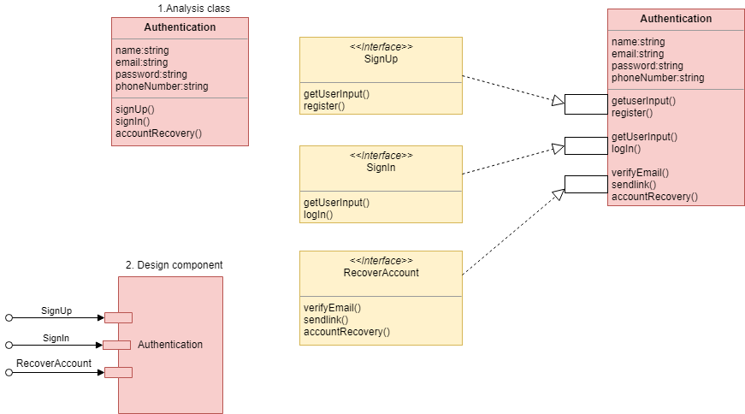

Figure : Elaboration of class Authentication

Instructor:

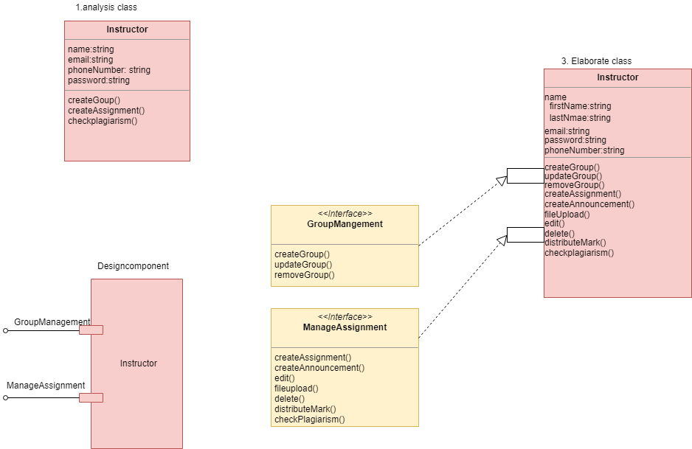

Figure : Class elaboration of Instructor

Student:

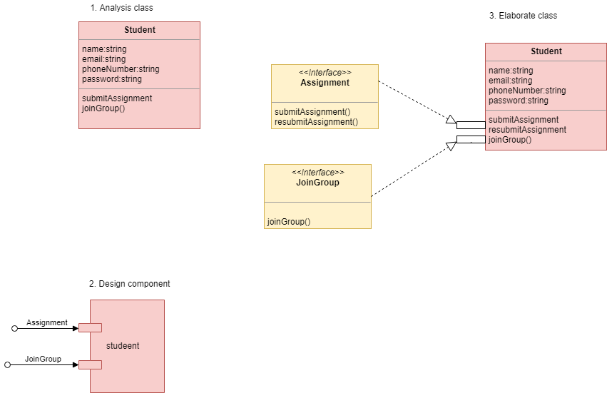

Figure : Class elaboration of Student

System:

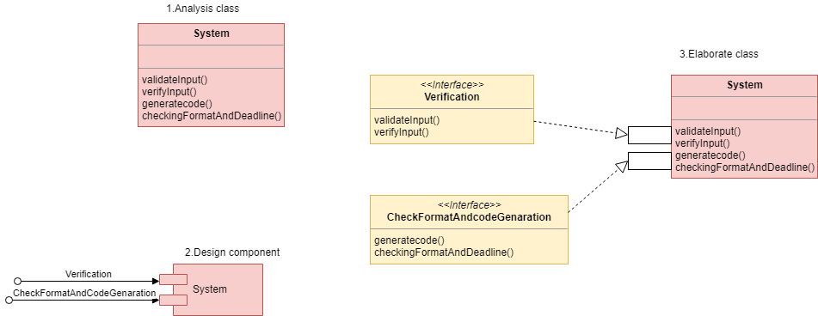

Figure : Class elaboration of System

## Collaboration Details: